Steven Kim  
Mr. Mason  
Adv Cisco CCNP P1,2  
IPv6 Routing on 7 different networks

**Purpose**

The purpose of this lab is to familiarize myself with IPv6, more specifically, basic IPv6 address assignments and routing protocols such as RIPng. Throughout this lab, I was required to use Layer 3 Switches (Catalyst 3560 and Catalyst 6500 Switches) that lead me to be accustomed to new IPv6 devices. This lab also required me to research ipv6 routing protocols that I have not learned. Finally, this lab required me to manage and route a complex network topology, with 7 different networks, a skill that is essential for a network engineer.

**Background Information on lab concepts**

IPv6, or Internet Protocol version 6, is the most recent version of IPs that has replaced Internet Protocol version 4 (IPv4). Such implementation was required for the growing need for new addresses, for IPv6 could provide more than people needed. It is thus crucial to know the use and implementation of IPv6.  
 RIPng, or Routing Information Protocol next generation, is a protocol that enables routing information to be transferred across different networks. RIP is a distance-vector protocol that uses hop counts as its metric.

**Lab Summary**

In this lab, I set up 2 Catalyst 2901 routers, 2 Catalyst 2811 routers, 2 Catalyst 3560 Switches, and 1 Catalyst 6500 Switch. As soon as I plugged in the appropriate cables, I began configuring the IPv6 in Routers with the knowledge that I acquired in CCNA, which is enabling IPv6 on each interface and setting up RIPng (see commands in the Lab Commands section). After that, I began to configure Switches thinking that Layer 3 Switches are practically Routers, only to realize that certain commands were needed to enable routing (Layer 3) and IPv6.  
 I attempted to figure out the appropriate commands by researching. This task was not simple at all, for there were a vast number of different commands that were dispersed throughout the internet. After 30 minutes on the internet and typing endless question marks, I finally was able to figure out that the commands *Switch (config)# sdm prefer dual-ipv4-and-ipv6 routing* and *Switch #* *reload* are initially required.  
 To ensure that the 7 networks can communicate, I used the commands **show ipv6 int brief** and **show ipv6 route** to check which networks have IPv6 enabled. Initially, only 4 routers were marked with an “R,” so I went back to the routers that were responsible for the missing networks. The main problem was that the ports were shutdown, since I did not copy and paste the **no shutdown** command when working on the lab the day after. After the routing table was complete, I issued the **tracert [ipv6-address]** command and verified that communication between hosts, which included 7 different networks, was enabled.

**Lab Commands**

To initially enable IPv6 on routers, the command *Router (config)# ipv6 unicast-*routing must be issued. The interfaces then need to be set up with the appropriate IPv6 addresses. There are two ways to do this – issuing the command *Router (config)# ipv6 address [network::/64] eui-64*, or *Router (config)# ipv6 address [network::number/64].* I used the eui-64 command to dynamically assign an IPv6 address. After that, the routing protocols need to be enabled; I issued the command *Router (config-if)# ipv6 rip [word] enable* and *Router (config)# ipv6 router rip [word]* to enable RIPng on routers.  
 The commands for configuring switches are slightly different. The command *Switch(config)# ipv6 unicast-*routing can’t be issued, thus the command *Switch (config)# sdm prefer dual-ipv4-and-ipv6 routing* and *Switch #* *reload* needs to be executed first. After that, the command *Switch (config)# ip routing* must be enabled for a Catalyst 3560 Switch to function as a layer 3 Switch. The rest are the same with routers. Note that the Catalyst 6500 does not need these commands unique on Layer 3 Switches.  
 To set up IPv6 addresses on hosts, simply click control panel then network settings, change adapter settings, and finally the IPv6 protocol. The default gateway is the IPv6 of the closest interface of the host.  
 As mentioned in the Lab Summary section, issue the commands *Router (config)# show ipv6 int brief, Router (config)# show ipv6 route*, and the *tracert* command (in cmd) to troubleshoot. Routing tables must be filled with a “R”, a “C,” or a “L” for every network to verify that the networks are part of the communication.

**Network Diagram with IP’s**

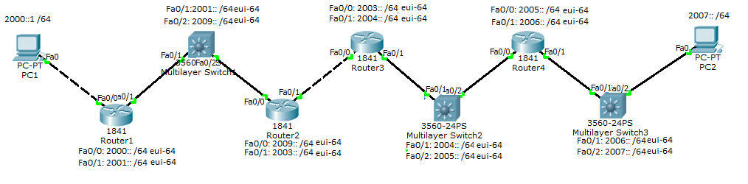

Note that Multilayer Switch 3 is the Catalyst 6500 Switch.

**Configurations**

Tracert from PC1 to PC2

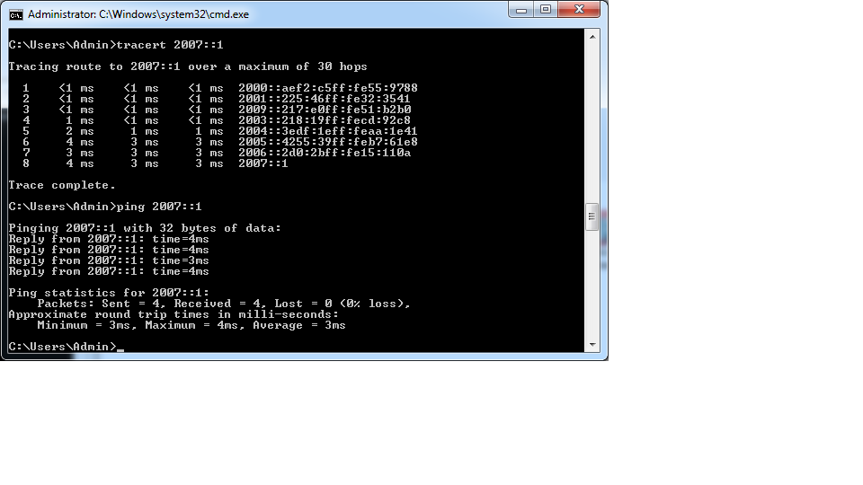

Tracert from PC2 to PC1

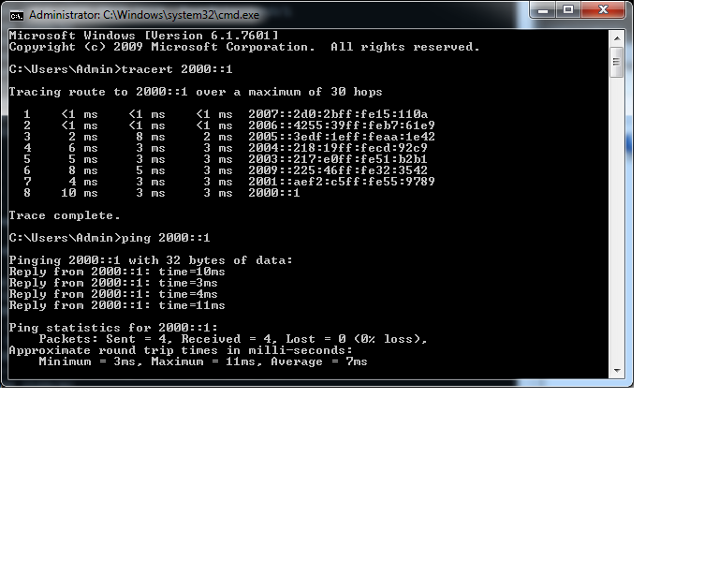

**ipconfig on PC1**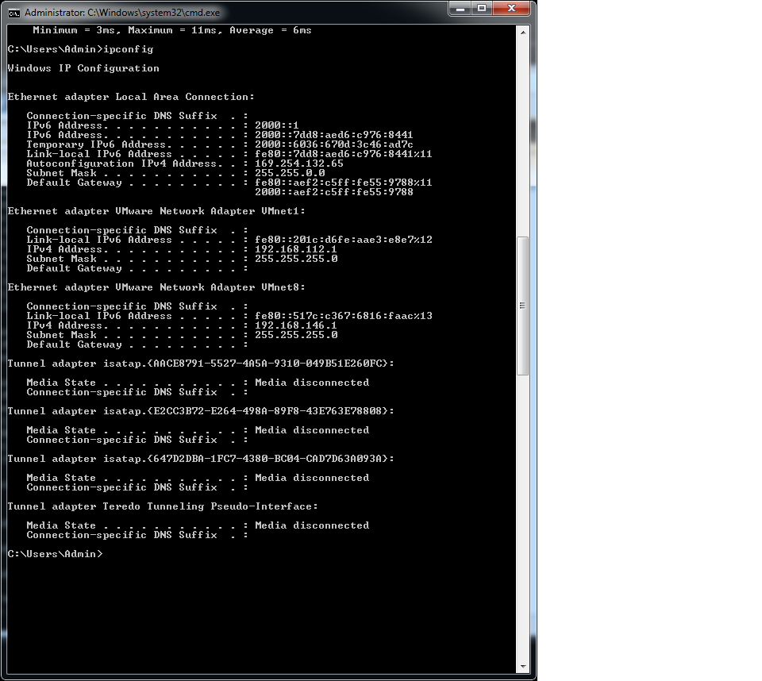

**ipconfig on PC2**

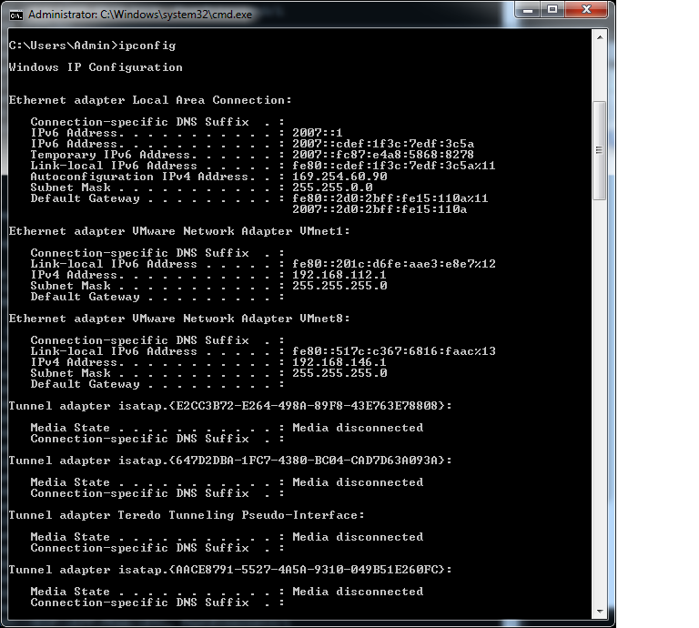

**Switch 3 (Catalyst 6500)**

S3#sh run

hostname S3

!

ipv6 unicast-routing

mls flow ip destination

mls flow ipx destination

no mls acl tcam share-global

!

interface FastEthernet4/1

no ip address

no shutdown

ipv6 address 2006::/64 eui-64

ipv6 rip Cisco enable

!

interface FastEthernet4/2

no ip address

no shutdown

ipv6 address 2007::/64 eui-64

ipv6 rip Cisco enable

!

!

ipv6 router rip Cisco

S3(config)#do sh ipv6 route

IPv6 Routing Table - 12 entries

Codes: C - Connected, L - Local, S - Static, R - RIP, B - BGP

U - Per-user Static route

I1 - ISIS L1, I2 - ISIS L2, IA - ISIS interarea, IS - ISIS summary

O - OSPF intra, OI - OSPF inter, OE1 - OSPF ext 1, OE2 - OSPF ext 2

ON1 - OSPF NSSA ext 1, ON2 - OSPF NSSA ext 2

R 2000::/64 [120/7]

via FE80::4255:39FF:FEB7:61E9, FastEthernet4/1

R 2001::/64 [120/6]

via FE80::4255:39FF:FEB7:61E9, FastEthernet4/1

R 2003::/64 [120/4]

via FE80::4255:39FF:FEB7:61E9, FastEthernet4/1

R 2004::/64 [120/3]

via FE80::4255:39FF:FEB7:61E9, FastEthernet4/1

R 2005::/64 [120/2]

via FE80::4255:39FF:FEB7:61E9, FastEthernet4/1

C 2006::/64 [0/0]

via ::, FastEthernet4/1

L 2006::2D0:2BFF:FE15:110A/128 [0/0]

via ::, FastEthernet4/1

C 2007::/64 [0/0]

via ::, FastEthernet4/2

L 2007::2D0:2BFF:FE15:110A/128 [0/0]

via ::, FastEthernet4/2

R 2009::/64 [120/5]

via FE80::4255:39FF:FEB7:61E9, FastEthernet4/1

L FE80::/10 [0/0]

via ::, Null0

L FF00::/8 [0/0]

via ::, Null0

**Router 3**

R3#sh run

hostname R3

!

ipv6 unicast-routing

ipv6 cef

ip source-route

ip cef

!

!

interface GigabitEthernet0/0

no ip address

no shutdown

duplex auto

speed auto

ipv6 address 2003::/64 eui-64

ipv6 rip Cisco enable

!

!

interface GigabitEthernet0/1

no ip address

no shutdown

duplex auto

speed auto

ipv6 address 2004::/64 eui-64

ipv6 rip Cisco enable

!

!

interface Serial0/0/0

no ip address

shutdown

clock rate 2000000

!

!

interface Serial0/0/1

no ip address

shutdown

clock rate 2000000

!

!

!

ip forward-protocol nd

!

no ip http server

no ip http secure-server

!

!

ipv6 router rip Cisco

!

!

!

!

!

!

!

control-plane

!

!

!

line con 0

line aux 0

line vty 0 4

login

!

scheduler allocate 20000 1000

end

IPv6 Routing Table - Default - 11 entries

Codes: C - Connected, L - Local, S - Static, U - Per-user Static route

B - BGP, M - MIPv6, R - RIP, I1 - ISIS L1

I2 - ISIS L2, IA - ISIS interarea, IS - ISIS summary, D - EIGRP

EX - EIGRP external

O - OSPF Intra, OI - OSPF Inter, OE1 - OSPF ext 1, OE2 - OSPF ext 2

ON1 - OSPF NSSA ext 1, ON2 - OSPF NSSA ext 2

R 2000::/64 [120/4]

via FE80::217:E0FF:FE51:B2B1, FastEthernet0/0

R 2001::/64 [120/3]

via FE80::217:E0FF:FE51:B2B1, FastEthernet0/0

C 2003::/64 [0/0]

via FastEthernet0/0, directly connected

L 2003::218:19FF:FECD:92C8/128 [0/0]

via FastEthernet0/0, receive

C 2004::/64 [0/0]

via FastEthernet0/1, directly connected

L 2004::218:19FF:FECD:92C9/128 [0/0]

via FastEthernet0/1, receive

R 2005::/64 [120/2]

via FE80::3EDF:1EFF:FEAA:1E41, FastEthernet0/1

R 2006::/64 [120/3]

via FE80::3EDF:1EFF:FEAA:1E41, FastEthernet0/1

R 2007::/64 [120/4]

via FE80::3EDF:1EFF:FEAA:1E41, FastEthernet0/1

R 2009::/64 [120/2]

via FE80::217:E0FF:FE51:B2B1, FastEthernet0/0

L FF00::/8 [0/0]

via Null0, receive

**Router 4:**

R4#sh run

!

version 15.0

service timestamps debug datetime msec

service timestamps log datetime msec

no service password-encryption

!

hostname R4

!

boot-start-marker

boot-end-marker

!

!

no aaa new-model

!

!

!

memory-size iomem 25

!

ipv6 unicast-routing

ipv6 cef

ip source-route

ip cef

!

!

!

!

redundancy

!

!

!

!

!

!

!

!

!

interface GigabitEthernet0/0

no ip address

no shutdown

duplex auto

speed auto

ipv6 address 2005::/64 eui-64

ipv6 rip Cisco enable

!

!

interface GigabitEthernet0/1

no ip address

no shutdown

duplex auto

speed auto

ipv6 address 2006::/64 eui-64

ipv6 rip Cisco enable

!

!

interface Serial0/0/0

no ip address

shutdown

no fair-queue

clock rate 2000000

!

!

interface Serial0/0/1

no ip address

shutdown

clock rate 2000000

!

!

!

ip forward-protocol nd

!

no ip http server

no ip http secure-server

!

!

ipv6 router rip Cisco

!

!

!

!

!

!

!

control-plane

!

!

!

line con 0

line aux 0

line vty 0 4

login

!

scheduler allocate 20000 1000

end

R4#sh ipv6 route

IPv6 Routing Table - default - 11 entries

Codes: C - Connected, L - Local, S - Static, U - Per-user Static route

B - BGP, HA - Home Agent, MR - Mobile Router, R - RIP

I1 - ISIS L1, I2 - ISIS L2, IA - ISIS interarea, IS - ISIS summary

D - EIGRP, EX - EIGRP external, ND - Neighbor Discovery

O - OSPF Intra, OI - OSPF Inter, OE1 - OSPF ext 1, OE2 - OSPF ext 2

ON1 - OSPF NSSA ext 1, ON2 - OSPF NSSA ext 2

R 2000::/64 [120/6]

via FE80::3EDF:1EFF:FEAA:1E42, GigabitEthernet0/0

R 2001::/64 [120/5]

via FE80::3EDF:1EFF:FEAA:1E42, GigabitEthernet0/0

R 2003::/64 [120/3]

via FE80::3EDF:1EFF:FEAA:1E42, GigabitEthernet0/0

R 2004::/64 [120/2]

via FE80::3EDF:1EFF:FEAA:1E42, GigabitEthernet0/0

C 2005::/64 [0/0]

via GigabitEthernet0/0, directly connected

L 2005::4255:39FF:FEB7:61E8/128 [0/0]

via GigabitEthernet0/0, receive

C 2006::/64 [0/0]

via GigabitEthernet0/1, directly connected

L 2006::4255:39FF:FEB7:61E9/128 [0/0]

via GigabitEthernet0/1, receive

R 2007::/64 [120/2]

via FE80::2D0:2BFF:FE15:110A, GigabitEthernet0/1

R 2009::/64 [120/4]

via FE80::3EDF:1EFF:FEAA:1E42, GigabitEthernet0/0

L FF00::/8 [0/0]

via Null0, receive

**Router 1**

R1#sh run

Current configuration : 1403 bytes

!

version 12.4

service timestamps debug datetime msec

service timestamps log datetime msec

no service password-encryption

!

hostname R1

!

boot-start-marker

boot-end-marker

!

logging message-counter syslog

!

no aaa new-model

memory-size iomem 10

!

dot11 syslog

ip source-route

!

!

ip cef

!

!

ipv6 unicast-routing

ipv6 cef

!

multilink bundle-name authenticated

!

!

!

!

!

!

!

interface Gi0/0

no ip address

duplex auto

speed auto

no shutdown

ipv6 address 2000::/64 eui-64

ipv6 rip Cisco enable

!

interface G0/1

no ip address

duplex auto

speed auto

no shutdown

ipv6 address 2001::/64 eui-64

ipv6 rip Cisco enable

!

interface FastEthernet0/3/0

!

interface FastEthernet0/3/1

!

interface FastEthernet0/3/2

!

interface FastEthernet0/3/3

!

interface Serial0/0/0

no ip address

shutdown

no fair-queue

clock rate 2000000

!

interface Serial0/0/1

no ip address

shutdown

clock rate 2000000

!

interface Serial0/1/0

no ip address

shutdown

clock rate 2000000

!

interface Serial0/1/1

no ip address

shutdown

clock rate 2000000

!

interface Vlan1

no ip address

shutdown

!

ip forward-protocol nd

no ip http server

no ip http secure-server

!

!

!

ipv6 router rip Cisco

!

!

!

!

line con 0

line aux 0

line vty 0 4

login

!

scheduler allocate 20000 1000

end

IPv6 Routing Table - default - 11 entries

Codes: C - Connected, L - Local, S - Static, U - Per-user Static route

B - BGP, R - RIP, I1 - ISIS L1, I2 - ISIS L2

IA - ISIS interarea, IS - ISIS summary, D - EIGRP, EX - EIGRP external

ND - Neighbor Discovery, l - LISP

O - OSPF Intra, OI - OSPF Inter, OE1 - OSPF ext 1, OE2 - OSPF ext 2

ON1 - OSPF NSSA ext 1, ON2 - OSPF NSSA ext 2

C 2000::/64 [0/0]

via GigabitEthernet0/0, directly connected

L 2000::AEF2:C5FF:FE55:9788/128 [0/0]

via GigabitEthernet0/0, receive

C 2001::/64 [0/0]

via GigabitEthernet0/1, directly connected

L 2001::AEF2:C5FF:FE55:9789/128 [0/0]

via GigabitEthernet0/1, receive

R 2003::/64 [120/3]

via FE80::225:46FF:FE32:3541, GigabitEthernet0/1

R 2004::/64 [120/4]

via FE80::225:46FF:FE32:3541, GigabitEthernet0/1

R 2005::/64 [120/5]

via FE80::225:46FF:FE32:3541, GigabitEthernet0/1

R 2006::/64 [120/6]

via FE80::225:46FF:FE32:3541, GigabitEthernet0/1

R 2007::/64 [120/7]

via FE80::225:46FF:FE32:3541, GigabitEthernet0/1

R 2009::/64 [120/2]

via FE80::225:46FF:FE32:3541, GigabitEthernet0/1

L FF00::/8 [0/0]

via Null0, receive

**Router 2**

R2#sh run

Current configuration : 1241 bytes

!

version 12.4

service timestamps debug datetime msec

service timestamps log datetime msec

no service password-encryption

!

hostname R2

!

boot-start-marker

boot-end-marker

!

logging message-counter syslog

!

no aaa new-model

memory-size iomem 10

!

dot11 syslog

ip source-route

!

!

ip cef

!

!

no ip domain lookup

ipv6 unicast-routing

ipv6 cef

!

!

!

!

!

!

interface FastEthernet0/0

no ip address

no shutdown

duplex auto

speed auto

ipv6 address 2009::/64 eui-64

ipv6 rip Cisco enable

!

interface FastEthernet0/1

no ip address

no shutdown

duplex auto

speed auto

ipv6 address 2003::/64 eui-64

ipv6 rip Cisco enable

!

interface Serial0/0/0

no ip address

shutdown

clock rate 2000000

!

interface Serial0/0/1

no ip address

shutdown

clock rate 64000

!

interface Serial0/1/0

no ip address

shutdown

clock rate 64000

!

interface Serial0/1/1

no ip address

shutdown

clock rate 2000000

!

ip forward-protocol nd

no ip http server

no ip http secure-server

!

!

!

ipv6 router rip Cisco

!

!

!

!

!

!

!

!

!

!

line con 0

line aux 0

line vty 0 4

login

!

scheduler allocate 20000 1000

end

IPv6 Routing Table - Default - 11 entries

Codes: C - Connected, L - Local, S - Static, U - Per-user Static route

B - BGP, M - MIPv6, R - RIP, I1 - ISIS L1

I2 - ISIS L2, IA - ISIS interarea, IS - ISIS summary, D - EIGRP

EX - EIGRP external

O - OSPF Intra, OI - OSPF Inter, OE1 - OSPF ext 1, OE2 - OSPF ext 2

ON1 - OSPF NSSA ext 1, ON2 - OSPF NSSA ext 2

R 2000::/64 [120/3]

via FE80::225:46FF:FE32:3542, FastEthernet0/0

R 2001::/64 [120/2]

via FE80::225:46FF:FE32:3542, FastEthernet0/0

C 2003::/64 [0/0]

via FastEthernet0/1, directly connected

L 2003::217:E0FF:FE51:B2B1/128 [0/0]

via FastEthernet0/1, receive

R 2004::/64 [120/2]

via FE80::218:19FF:FECD:92C8, FastEthernet0/1

R 2005::/64 [120/3]

via FE80::218:19FF:FECD:92C8, FastEthernet0/1

R 2006::/64 [120/4]

via FE80::218:19FF:FECD:92C8, FastEthernet0/1

R 2007::/64 [120/5]

via FE80::218:19FF:FECD:92C8, FastEthernet0/1

C 2009::/64 [0/0]

via FastEthernet0/0, directly connected

L 2009::217:E0FF:FE51:B2B0/128 [0/0]

via FastEthernet0/0, receive

L FF00::/8 [0/0]

via Null0, receive

**Switch 2 (Catalyst 3560)**

S2#sh run

version 12.2

no service pad

service timestamps debug uptime

service timestamps log uptime

no service password-encryption

!

hostname S2

!

boot-start-marker

boot-end-marker

!

!

!

!

sdm prefer dual-ipv4-and-ipv6 routing

no aaa new-model

system mtu routing 1500

authentication mac-move permit

ip subnet-zero

!

!

ipv6 unicast-routing

!

!

!

!

!

!

spanning-tree mode pvst

spanning-tree etherchannel guard misconfig

spanning-tree extend system-id

!

vlan internal allocation policy ascending

!

!

!

!

interface FastEthernet0/1

no switchport

no ip address

no shutdown

ipv6 address 2004::/64 eui-64

ipv6 rip Cisco enable

!

interface FastEthernet0/2

no switchport

no ip address

no shutdown

ipv6 address 2005::/64 eui-64

ipv6 rip Cisco enable

!

!

interface Vlan1

no ip address

shutdown

!

ip classless

ip http server

ip http secure-server

!

!

ip sla enable reaction-alerts

ipv6 router rip Cisco

!

!

!

!

!

line con 0

line vty 0 4

login

line vty 5 15

login

!

end

S2#sh ipv6 route

IPv6 Routing Table - Default - 11 entries

Codes: C - Connected, L - Local, S - Static, U - Per-user Static route

B - BGP, R - RIP, D - EIGRP, EX - EIGRP external

O - OSPF Intra, OI - OSPF Inter, OE1 - OSPF ext 1, OE2 - OSPF ext 2

ON1 - OSPF NSSA ext 1, ON2 - OSPF NSSA ext 2

R 2000::/64 [120/5]

via FE80::218:19FF:FECD:92C9, FastEthernet0/1

R 2001::/64 [120/4]

via FE80::218:19FF:FECD:92C9, FastEthernet0/1

R 2003::/64 [120/2]

via FE80::218:19FF:FECD:92C9, FastEthernet0/1

C 2004::/64 [0/0]

via FastEthernet0/1, directly connected

L 2004::3EDF:1EFF:FEAA:1E41/128 [0/0]

via FastEthernet0/1, receive

C 2005::/64 [0/0]

via FastEthernet0/2, directly connected

L 2005::3EDF:1EFF:FEAA:1E42/128 [0/0]

via FastEthernet0/2, receive

R 2006::/64 [120/2]

via FE80::4255:39FF:FEB7:61E8, FastEthernet0/2

R 2007::/64 [120/3]

via FE80::4255:39FF:FEB7:61E8, FastEthernet0/2

R 2009::/64 [120/3]

via FE80::218:19FF:FECD:92C9, FastEthernet0/1

L FF00::/8 [0/0]

via Null0, receive

**Switch 1 (Catalyst 3560)**

S1#sh run

Current configuration : 2376 bytes

!

version 12.2

no service pad

service timestamps debug uptime

service timestamps log uptime

no service password-encryption

!

hostname S1

!

boot-start-marker

boot-end-marker

!

!

!

!

sdm prefer dual-ipv4 routing

no aaa new-model

system mtu routing 1500

authentication mac-move permit

ip subnet-zero

ip routing

!

!

ipv6 unicast-routing

!

!

!

!

!

!

spanning-tree mode pvst

spanning-tree etherchannel guard misconfig

spanning-tree extend system-id

!

vlan internal allocation policy ascending

!

!

!

!

interface FastEthernet0/1

no switchport

no shutdown

no ip address

ipv6 address 2001::/64 eui-64

ipv6 rip Cisco enable

!

interface FastEthernet0/2

no switchport

no shutdown

no ip address

ipv6 address 2009::/64 eui-64

ipv6 rip Cisco enable

!

interface Vlan1

ip address 192.168.1.1 255.255.255.0

!

ip classless

ip http server

ip http secure-server

!

!

ip sla enable reaction-alerts

ipv6 router rip Cisco

!

!

!

!

!

line con 0

line vty 0 4

login

line vty 5 15

login

!

end

Routing Table:

IPv6 Routing Table - Default - 11 entries

Codes: C - Connected, L - Local, S - Static, U - Per-user Static route

B - BGP, R - RIP, D - EIGRP, EX - EIGRP external

O - OSPF Intra, OI - OSPF Inter, OE1 - OSPF ext 1, OE2 - OSPF ext 2

ON1 - OSPF NSSA ext 1, ON2 - OSPF NSSA ext 2

R 2000::/64 [120/2]

via FE80::AEF2:C5FF:FE55:9789, FastEthernet0/1

C 2001::/64 [0/0]

via FastEthernet0/1, directly connected

L 2001::225:46FF:FE32:3541/128 [0/0]

via FastEthernet0/1, receive

R 2003::/64 [120/2]

via FE80::217:E0FF:FE51:B2B0, FastEthernet0/2

R 2004::/64 [120/3]

via FE80::217:E0FF:FE51:B2B0, FastEthernet0/2

R 2005::/64 [120/4]

via FE80::217:E0FF:FE51:B2B0, FastEthernet0/2

R 2006::/64 [120/5]

via FE80::217:E0FF:FE51:B2B0, FastEthernet0/2

R 2007::/64 [120/6]

via FE80::217:E0FF:FE51:B2B0, FastEthernet0/2

C 2009::/64 [0/0]

via FastEthernet0/2, directly connected

L 2009::225:46FF:FE32:3542/128 [0/0]

via FastEthernet0/2, receive

L FF00::/8 [0/0]

via Null0, receive

**Problems**

One of the major problems that I encountered was having to figure out the protocol that enabled ipv6 routing on the Switches. This process consumed the most time, for the commands on the internet were difficult to find. Also, Layer 1 problems were prevalent; as I saved my configurations in a separate text document, the “no shutdown” command was not typed, often shutting down the ports and leaving the routing table blank.

**Conclusion**

The overall result of this lab was satisfying; I managed to enable communication among 7 different networks. Although Layer 1 issues as well as the process of researching protocols consumed more time than I expected, I could implement the knowledge I gained as quickly and efficiently as possible. Moreover, this lab helped me gain a better understanding of how the CCNP racks worked. I was finally able to be accustomed to setting up IPv6 and RIPng and configuring Catalyst 3560 and 6500 Switches to enable communication in Layer 3.